Evolve Edge Pitch Deck Structure

Contents
Contents
Overview
Status
Slides
Title
Mission/vision
Need/impact
Solution
Benefits
Market / niche size
Product
Competition
Unfair advantage
Business model
Traction / achievements
Go-to-market strategy
Business plan
Team / story
Why now?
Product Roadmap
Pitch notes
Investment need
Contact
Appendices
References
Competition

Overview
This document describes the structure of the full pre-seed pitch deck. This deck is to be used to send to investors when trying to obtain pre-seed funding. It is not for the presentation deck (i.e. the deck used when presenting to investors).

Status

Slide | Status | Notes
Title | MOVED TO DECK
Mission/vision | MOVED TO DECK
Need/impact | MOVED TO DECK
Solution | Completed
Benefits | MOVED TO DECK
Market/niche size | Completed
Product | N/A
Competition | MOVED TO DECK
Unfair advantage | MOVED TO DECK
Business model | MOVED TO DECK
Traction/achievements | MOVED TO DECK
Go-to-market strategy | MOVED TO DECK
Business plan | MOVED TO DECK
Team/story | MOVED TO DECK
Why now? | MOVED TO DECK
Product Roadmap | MOVED TO DECK
Investment need | MOVED TO DECK
Contact | MOVED TO DECK
Appendices | MOVED TO DECK
References | MOVED TO DECK
Competition | MOVED TO DECK

Slides

Title
Status: MOVED TO DECK

Logo: 
Name: Evolve Edge (included in logo)
Impact statement: Turning compliance from a costly burden into a competitive edge

Mission/vision
Status: MOVED TO DECK

Our mission: To empower regulated businesses by making compliance audit processes radically simpler, smarter, and faster.

Our vision: A world where compliance is no longer a bottleneck, but a competitive advantage - with Evolve Edge becoming the global standard for intelligent, automated compliance.

Need/impact
Status: MOVED TO DECK

Title: Compliance is unavoidable - but it’s painfully inefficient and dangerously costly

- Audits are slow and complex → typically 6–12 months of preparation [1]
- Heavy reliance on consultants → costs enterprises $150k–$500k per year [2]
- High regulatory penalties → PCI fines up to $100k/month; HIPAA breaches up to $1.5m [3]
- Lost innovation and revenue → compliance delays stall product launches, funding rounds, and contracts [4]
- Manual, fragmented processes → compliance teams waste ~60% of audit time chasing documents [5]

Solution
Status: MOVED TO DECK

Title: Evolve Edge makes enterprises continuously audit-ready

A compliance automation platform that replaces manual audits and consultants with:

- Real-time monitoring
- Automated evidence collection
- Proactive remediation
- Instant audit preparation

Benefits
Status: MOVED TO DECK

Title: The benefits? Time saved, costs reduced, risks eliminated

- Audit-ready in days, not months → preparation cut from 6–12 months to ~3 days.
- Massive cost savings → reduces consultant spend of $150k–$500k per year.
- 87% efficiency gain → compliance engineer workload cut from 300 hours to 40.
- Proactive remediation → auto-patching fixes compliance issues as they arise, reducing risk at the source.
- Reduced risk exposure → prevents failed audits, fines, and reputational damage.
- Multi-framework coverage → PCI DSS, HIPAA, SOC 2, ISO 27001, FedRAMP.
- Scales with the enterprise → integrates into workflows (Jira, ServiceNow, Slack, GitHub, AWS, Azure).

Market / niche size
Status: MOVED TO DECK

Title: With a $1.3B global opportunity, Evolve Edge will capture $8M in year 1, growing to $1.25B per year by 2030

Market size: Market Size

 | 2026 |  | 2030 (CAGR 22% + expansion)
 | Annual revenue | Description | Annual revenue | Description
TAM | $1.3B | 39k organizations globally* | $2.9B | 86k organizations globally*
SAM | $456M | 15k organizations in US* | $2.9B | 86k organizations globally*
SOM | $8M | 456 organizations*  (1.7% of SAM) | $1.25B | 24k organizations*  (44% of SAM)

- $10k - $80k per year (small, medium & large organizations)

Product
Status: N/A

Competition
Status: MOVED TO DECK

Title: Only Evolve Edge delivers true continuous, automated compliance

CA: Competitive Analysis Summary

 | Vanta | Drata | SecureFrame | Evolve Edge
Continuous audit-readiness | NO | NO | NO | YES
Proactive remediation (auto-fix) | NO | NO | NO | YES
Audit time: days, not months | Months | Weeks–Months | Weeks–Months | 3 days
Automated evidence collection | PARTIAL* | PARTIAL* | PARTIAL* | YES
Cost reduction ($150k–$500k saved) | PARTIAL* | PARTIAL* | PARTIAL* | YES
Multi-framework coverage | PARTIAL* | PARTIAL* | PARTIAL* | YES
Enterprise workflow integration | PARTIAL* | PARTIAL* | PARTIAL* | YES

- See Appendix B

Unfair advantage
Status: MOVED TO DECK

Title: Evolve Edge’s unique blend of compliance expertise and AI-first automation creates lasting defensibility

Founder DNA: Kiel Green combines deep compliance experience (CISA, PCI DSS, HIPAA leadership) with AI/ML and cloud security expertise - rare hybrid credibility that competitors lack.
Proactive Remediation: Unlike all competitors, Evolve Edge won’t just monitor - it will fix compliance gaps automatically (auto-patching), embedding the product deeper into customer workflows.
Workflow Stickiness: Tight integrations with enterprise tools (Jira, ServiceNow, Slack, GitHub, AWS, Azure) make the platform the system of record for compliance, raising switching costs.
Multi-Framework Expansion: Customers typically start with one framework (e.g. HIPAA or PCI) and expand across SOC 2, ISO 27001, FedRAMP - driving high Net Revenue Retention (>120%).
Regulatory Lock-In: Compliance is mandatory and recurring; once embedded, Evolve Edge becomes mission-critical infrastructure.

Business model
Status: MOVED TO DECK

Title: Recurring SaaS revenue with tiered pricing and expansion

- Basic: $10k/year ($1k/month) - self-service, AI chatbot, knowledge base.
- Pro: $50k/year ($5k/month) - API access, priority support.
- Enterprise: $80k–$95k/year ($8k/month) - full compliance bundles, tailored support.
- Add-ons: $500–$5k per module - specialised frameworks & features.

Traction / achievements
Status: MOVED TO DECK

Title: Clear market demand and customers ready to buy

50% interviewed customers ready to purchase now
20% interviewed customers plan to purchase in the future

* 10 HealthTech & Fintech companies interviewed

Pitch notes
15 minute calls
70% have need

Go-to-market strategy
Status: MOVED TO DECK

Title: Focused U.S. launch, scalable multi-channel growth

Beachhead market: U.S. Financial Institutions (~14,800) and Healthcare Systems (~400 parent entities).
Sales model: Founder-led, high-touch demos and pilots → conversion to annual SaaS contracts.
Marketing tactics: Lean, low-cost channels - LinkedIn campaigns, webinars, and founder-led thought leadership.
Expansion: Europe and Hospitality/Retail in Year 3; global rollout in Year 4, with channel partners (MSPs, consultants, AWS Marketplace).

Business plan
Status: MOVED TO DECK

Title: Profitable in year 1 with total revenue of $1.25B after 5 years

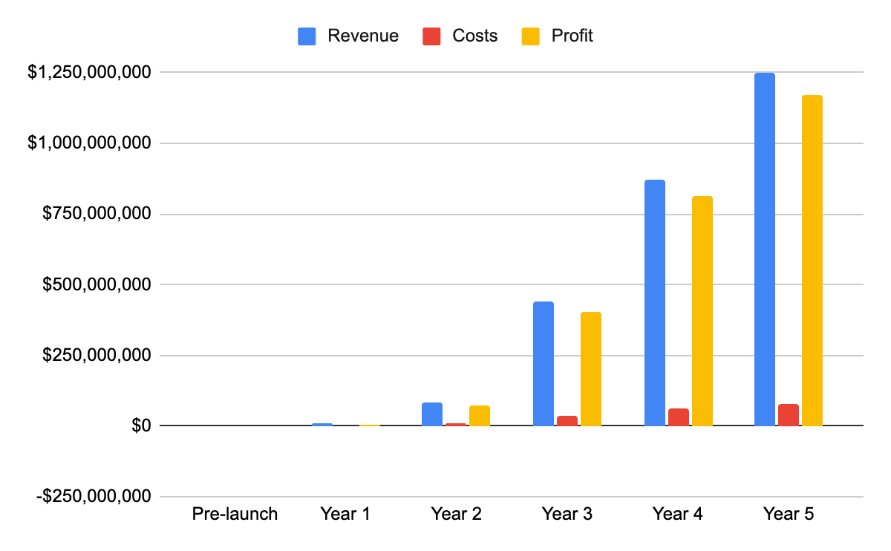
Year 2: Expansion to additional sectors and to UK/Europe

Key metrics:
CAC (Basic: $800, Pro: $1,200, Enterprise: $1,500)
Churn (Basic: 1%, Pro: 0.5%, Enterprise: 0.25%)

Team / story
Status: MOVED TO DECK

Title: Rare hybrid: compliance authority + technical depth



Kiel Green - Founder & CEO
- Hybrid expertise: Certified Information Systems Auditor (CISA) + AWS Certified Solutions Architect + Google Cloud Certified Data Engineer.
- Technical depth: Python, Terraform, Kubernetes, NLP/ML, cloud security; developed a patent-pending NLP engine for regulatory automation.
- Compliance authority: Led PCI DSS and HIPAA audits in financial and healthcare institutions; lived the pain of delays, fines, and wasted spend.
- Industry recognition: RSA Conference speaker on AI and compliance; published in RegTech and data privacy.
- Track record: Security architecture at Palo Alto Networks; supported regulated fintech deployments on AWS.
- Mission-driven: First-hand experiences in fintech and healthcare convinced him compliance must become a competitive advantage, not a bottleneck.


Stuart Prestedge – Startup Advisor/Mentor
- 37 years as Founder/CTO
- 8 startups, 23 products, 3 exits
- 10 years advising/mentoring tech startups
- Guided countless founders from concept to exit
- Expert in business, technology, and mindset
- Passionate about creating successful startups and impact

Why now?
Status: MOVED TO DECK

Title: Regulatory pressure is exploding - and AI makes automation possible now

Rising regulatory complexity: PCI DSS v4.0, HIPAA updates, GDPR enforcement, and FedRAMP expansion are driving urgent demand.
Escalating penalties & risk: Fines up to $100k/month (PCI DSS) and $1.5m (HIPAA breaches) make non-compliance untenable.
Inefficient status quo: Businesses spend 33–65 staff hours/month and $12k–$46k/month on compliance.
Proven market appetite: 15,000+ companies already use Vanta/Drata-type platforms - proving demand but leaving gaps unfilled.
Technology inflection point: Advances in AI/NLP and deep integrations now enable true continuous audit-readiness and proactive remediation.

Product Roadmap
Status: MOVED TO DECK

Title: From audit-ready MVP to AI-powered compliance leader
MVP (Within 6 months of funding)
- Frameworks: HIPAA + PCI DSS.
- Core features: automated evidence collection, compliance dashboards, risk detection.
- Integrations: AWS, GCP, GitHub, Slack.
Year 1
- Framework: SOC 2.
- Expanded integrations: Microsoft Azure + enterprise platforms.
- Enhanced automation: broader evidence library, automated reporting.
Year 2
- AI Auditor Copilot: regulatory Q&A, workflow assistance.
- Smart task routing, role-based dashboards.
Year 3
- Framework: FedRAMP-ready module for U.S. federal contractors & SaaS providers.
- Expanded internationalisation + compliance templates for global enterprises.
Year 4
- Framework: ISO 27001, SOX

Pitch notes
We start focused with HIPAA and PCI DSS, then expand rapidly into SOC 2, AI Copilot, and FedRAMP — building the category leader in proactive, automated compliance

Investment need
Status: MOVED TO DECK

Title: We are raising a $482k pre-seed round to develop, launch and reach profitability

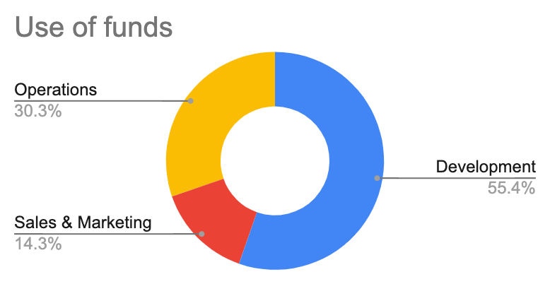

Milestones:
Launch, revenue, profitability & growth (no future round required)

Terms
SAFE note preferred

Contact
Status: MOVED TO DECK

Thank you!

Logo.png

Kiel Green, Founder & CEO

k.green@evolveedgeai.com

http://evolveedgeai.com/

Book a call

A massive market, painful problem, and unique solution - Evolve Edge is ready to lead. We’d love to share our vision with you in a call.

Appendices
Status: MOVED TO DECK

Title: Appendices

References
Status: MOVED TO DECK

Title: Appendix A - References

- Audits are slow and complex → typically 6–12 months of preparation:
  - Thomson Reuters. (2023). "2023 Cost of Compliance Report." Thomson Reuters Institute (https://www.thomsonreuters.com/en-us/posts/risk-fraud-compliance/2023-cost-of-compliance-report/). This annual report consistently details the increasing time and resource burden on compliance teams, including preparation times.
  - Protiviti. (2023). "2023 Next-Generation Compliance Survey." Protiviti (https://www.protiviti.com/us-en/survey/next-generation-compliance-survey). Discusses how manual processes and complex regulations lead to lengthy audit preparation cycles.
  - ISACA. (2022). "The State of IT Audit and Risk Management." ISACA Journal, Volume 3 (https://www.isaca.org/resources/isaca-journal/issues/2022/volume-3/the-state-of-it-audit-and-risk-management). A foundational source from a leading audit and compliance association, often citing preparation timelines.
  - Vanta. (2023). "The Ultimate Guide to SOC 2 Compliance." (https://www.vanta.com/resources/soc-2-compliance-guide). While a competitor, their public marketing content explicitly states that preparing for a SOC 2 audit "typically takes 3–12 months," validating the claim.
  - Drata. (2023). "How Long Does SOC 2 Compliance Take?" (https://www.drata.com/blog/how-long-does-soc-2-compliance-take). Another competitor's resource that confirms the multi-month timeline for audit preparation.
- Heavy reliance on consultants → costs enterprises $150k–$500k per year
  - Gartner. (2023). "Market Guide for IT Risk Management Solutions." Gartner (https://www.gartner.com/en/documents/4583196 (Paywalled)). Gartner data is industry gold standard. For your own knowledge, this report details spending on external consultants.
  - Panaseer. (2022). "The Cost of Cybersecurity Compliance Report." (https://panaseer.com/whitepapers/the-cost-of-cybersecurity-compliance/). This report breaks down compliance costs, highlighting the significant portion allocated to external consultants and advisory services.
  - Hyperproof. (2023). "The State of Compliance Operations Report." (https://hyperproof.io/resource/state-of-compliance-operations-report-2023/). This survey-based report provides data on how organizations budget for compliance, including outsourced services.
  - Deloitte. (2022). "A new era for compliance." Deloitte Insights (https://www2.deloitte.com/us/en/insights/industry/financial-services/future-of-compliance-financial-institutions.html). Discusses the high cost of the compliance function for financial institutions, a key target market for you.
  - Secureframe. (2023). "How Much Does SOC 2 Compliance Cost?" (https://secureframe.com/blog/soc-2-compliance-cost). Estimates consultant costs for SOC 2 specifically, which can be extrapolated to a multi-framework, enterprise environment.
- High regulatory penalties → PCI fines up to $100k/month; HIPAA breaches up to $1.5m
  - PCI Security Standards Council. (2022). "PCI DSS Quick Reference Guide." (https://www.pcisecuritystandards.org/document_library). The official PCI DSS documentation outlines the potential fines from acquiring banks, which can be up to $100,000 per month for non-compliance.
  - U.S. Department of Health & Human Services (HHS). (2023). "HIPAA for Professionals." (https://www.hhs.gov/hipaa/for-professionals/index.html). The official HHS site details the penalty structure for HIPAA violations, which can reach $1.5 million per year for repeated violations of an identical provision.
  - Federal Trade Commission (FTC). (2023). "PCI DSS-Related Enforcement." (https://www.ftc.gov/business-guidance/privacy-security). The FTC has brought actions against companies for misrepresenting their PCI DSS compliance, highlighting the financial and legal risks.
  - JD Supra. (2023). "2023 HIPAA Enforcement Review." (https://www.jdsupra.com/legalnews/2023-hipaa-enforcement-review-2972971/). Legal analyses often summarize annual enforcement actions and the staggering costs of settlements.
  - TokenEx. (2023). "The Ultimate Guide to PCI DSS Compliance." (https://www.tokenex.com/resources/blog/ultimate-guide-to-pci-dss-compliance/). Clearly outlines the potential financial penalties from card brands for PCI DSS non-compliance.
- Lost innovation and revenue → compliance delays stall product launches, funding rounds, and contracts
  - Accenture. (2022). "Compliance Risk Report." (https://www.accenture.com/us-en/insights/risk/compliance-risk-report).This report discusses how inefficient compliance functions can hinder strategic business objectives and growth.
  - Forbes Technology Council. (2022). "How Compliance Delays Can Stifle Innovation And How To Prevent It." (https://www.forbes.com/sites/forbestechcouncil/2022/07/05/how-compliance-delays-can-stifle-innovation-and-how-to-prevent-it/). A direct article from industry experts on the topic, perfect for supporting this claim.
  - Reference 3: McKinsey & Company. (2021). "The compliance journey: From focus on oversight to adding value." (https://www.mckinsey.com/capabilities/risk-and-resilience/our-insights/the-compliance-journey-from-focus-on-oversight-to-adding-value). Discusses how a modernized compliance function can enable business velocity rather than hinder it.
  - SANS Institute. (2022). "The Impact of Security and Compliance on Mergers and Acquisitions." (https://www.sans.org/white-papers/42232/). Details how compliance postures directly impact funding events like M&A and due diligence.
  - TechCrunch. (2023). "Why compliance is the silent killer of startup speed." (https://techcrunch.com/2023/04/19/why-compliance-is-the-silent-killer-of-startup-speed/). Industry publications frequently cover this pain point, especially in fintech and healthtech.
- Manual, fragmented processes → compliance teams waste ~60% of audit time chasing documents
  - Gartner. (2022). "How to Build an Integrated Risk Management Strategy." Gartner (https://www.gartner.com/en/documents/4017590 (Paywalled)). Gartner research often cites that risk and compliance professionals spend a majority of their time on manual data collection and assessment activities.
  - MetricStream. (2023). "The State of GRC Report." (https://www.metricstream.com/state-of-grc-report-2023.htm). Surveys consistently show that a lack of automation and integrated systems is the biggest challenge for GRC professionals.
  - ISACA. (2023). "State of IT Audit and Risk Management." (https://www.isaca.org/go/state-of-it-audit). This report highlights the inefficiencies in audit processes, including the time spent on evidence gathering.
  - Workiva. (2022). "The Cost of Compliance: A Study on the State of ESG and Regulatory Reporting." (https://www.workiva.com/resources/report/cost-compliance-study-state-esg-and-regulatory-reporting). While focused on ESG, the data on manual processes and time spent is highly transferable to security compliance audits.
  - KPMG. (2021). "The future of IT Audit." (https://kpmg.com/xx/en/home/insights/2021/06/the-future-of-it-audit.html). Discusses the shift from manual, retrospective audits to continuous, automated assurance, implicitly confirming the current inefficiency.

Competition
Status: MOVED TO DECK

Title: Appendix B - Competition

Notes from Competitive Analysis Summary

Notes | Vanta | Drata | SecureFrame
Automated evidence collection | Some integrations but manual uploads required | Automates evidence for SOC 2 only | Coverage limited to select frameworks
Cost reduction ($150k–$500k saved) | Reduces admin but still needs consultants | Dashboards cut time, not audit costs | Automation reduces some spend, not full consultant costs
Multi-framework coverage | Mainly SOC 2 & ISO 27001 | SOC 2, ISO 27001, HIPAA | Broader but shallow coverage

